AMERICAN HERDING BREEDS ASSN.

AND

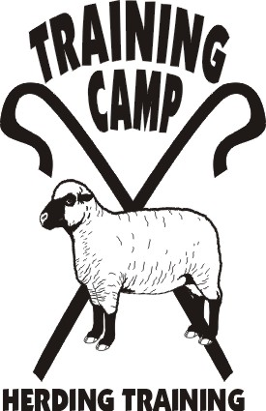

PRESENT

HERDING TRIAL

&

HERDING ARENA TRIAL
&
JUNIOR HERDING DOG TEST

August 4, 2007

LOCATION:

Myron Lindgren Farm Scandia, MN

OPEN TO ALL HERDING AND MIXED HERDING BREEDS
(DOGS AT LEAST 6 MONTHS OF AGE)

TRIAL CLASSES: HTD I, II, III – Sheep
HATD I, II, III – Sheep
Course 3 w/gather & ribbon pull

TEST CLASSES: JHD – Sheep

JUDGE: | Becky Beckmann
 | Stacy, MN

ENTRY LIMITS: 30 Total Runs

MAIL ENTRIES TO:
JoAnna Yund
4047 Sheridan Ave. So.
Minneapolis, MN 55410

ENTRY FEES ALL CLASSES:
PRE-ENTRY (Due July 20, 2007) $30/run
Day-Of (livestock available) $35/run

TRIAL CHAIR: JoAnna Yund
JoAnnaY@aol.com

NOTICE TO EXHIBITORS:

- Handlers Meeting for HTD will be at 9:00 a.m.
Handlers Meeting for HATD will follow.
Handlers Meeting for JHD will follow above classes

- Competitors are responsible for cleaning up after their dogs. All dogs must be on leash when not competing.

- Competitors assume financial responsibility for medication and/or veterinary care and/or replacement value of stock for any injury caused by them or their dog(s).

Fields for HTD have a very steep hill as well as rock and tree obstacles. Handlers and their dogs should be sure they are able to physically negotiate the courses.

DIRECTIONS TO SITE

FROM EAST/WEST: Take Hwy 36 to Hwy 15 (Manning) go north to the third stop sign. This is Hwy 4 (170th St.) Turn right (east) for 4.5 miles to Parade. Turn left and left again on Old Marine Trail. Farm is on the east (right) side of the road. Driveway is next to the windbreak of trees.

FROM NORTH/SOUTH: Take I-35 to Hwy 97 and go east to Scandia (approx 15 miles). At Hwy 52 – this is Oakhill (just past Scandia Elementary School) turn right (south). Go approx. 1 mile to Oxboro and turn right past Sand Lake to the “T”, turn left on Old Marine Trail. The farm is on the east (left) side of the road. Driveway is next to the windbreak of trees.

